# PRACTICAL 2: Creating account, repository on Github s and cloning repository in Github

1. **Creating account: -**

**Step1: - Search Github on Google and click on the official link of Github.**

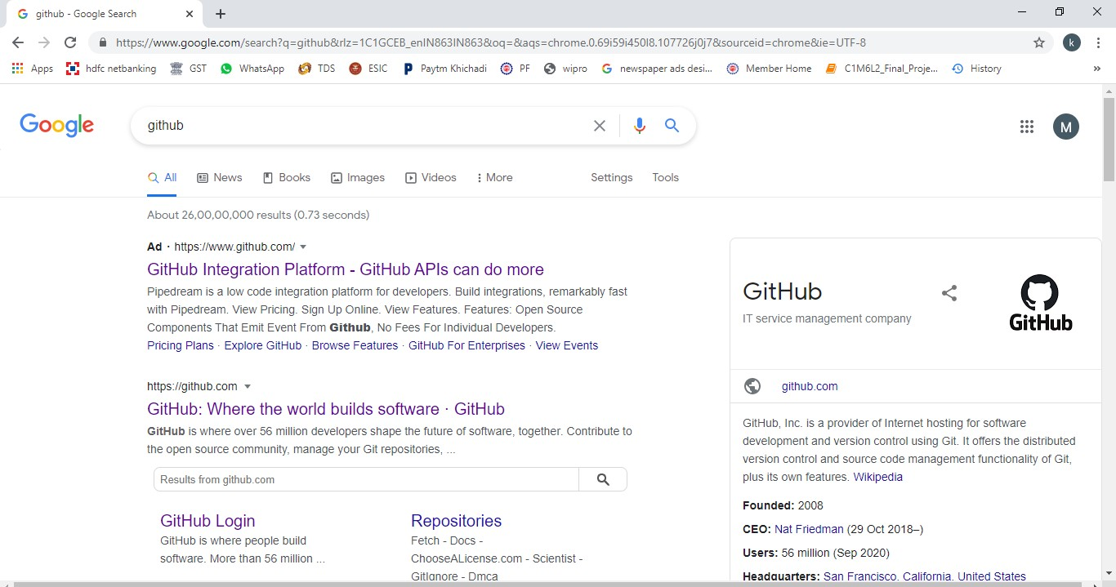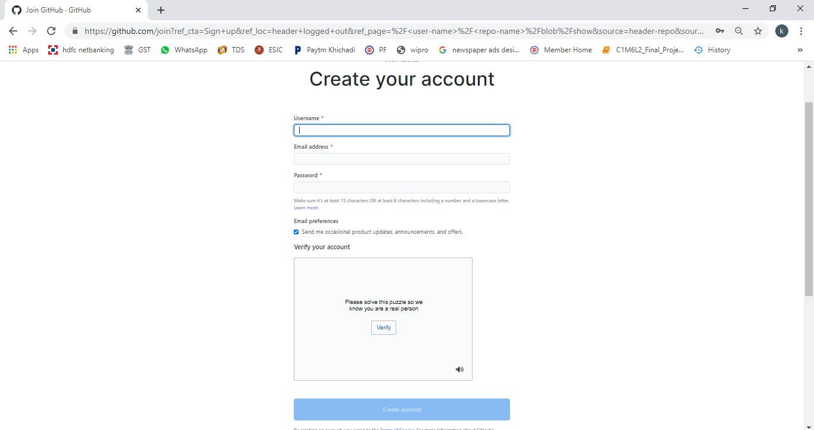

**here you have to fill all necessary information which is star marked.**

Step 2: Click on the sign up button to create an account on Github.

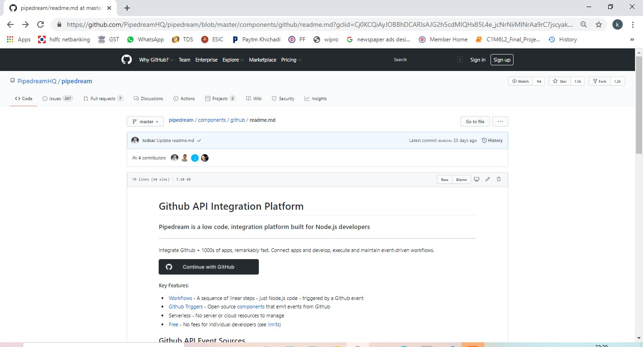

Step 3: When you click on the signup button you will reach on this page

Step 4: After fill all the information verify your account and click on the Create Account button. Now your account is created.

1. **Creating repository:**

Step 1: To create repository click on the + button .

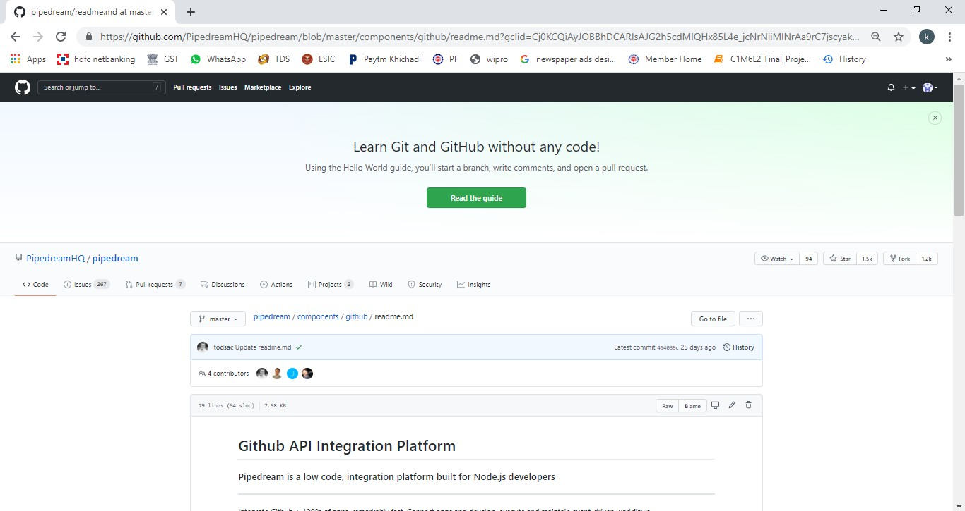

Step 2: Click on New repository to make your repository.

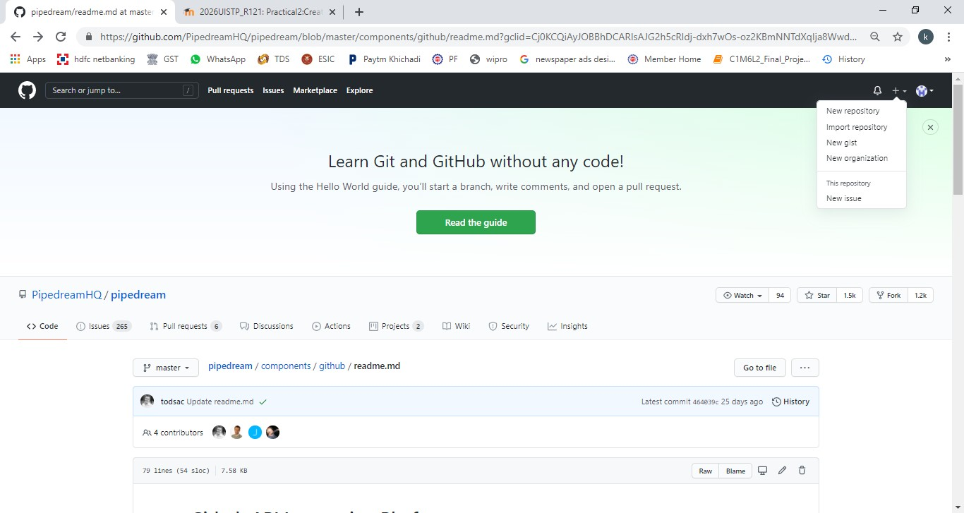

Step 3: After clicking on the New repository you reach on this page here you have to give your Repository name, click on the private or public button.

Description: It is optional, so if you want to describe something about your repository then fill the description field with necessary information

1. **Private: If you want no one can access your repository then click on private button.**
2. **Public: If you want other people can access your repository then click on public button.**

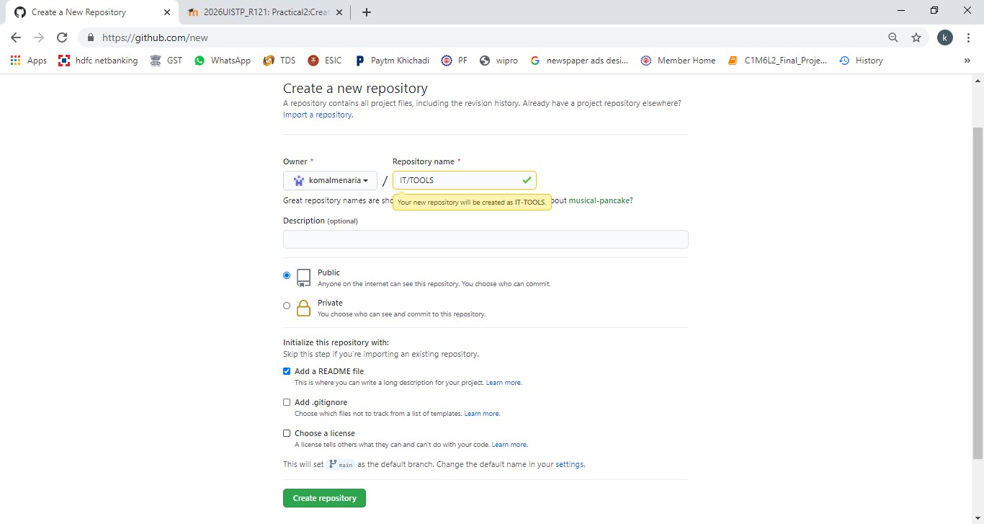

SELECT ONE OF THEM

Step 4: In the last click on the create repository button.

1. **Cloning repository:**

After clicking on the create repository button you will reach on this page Step 1:Click on the Add file button .

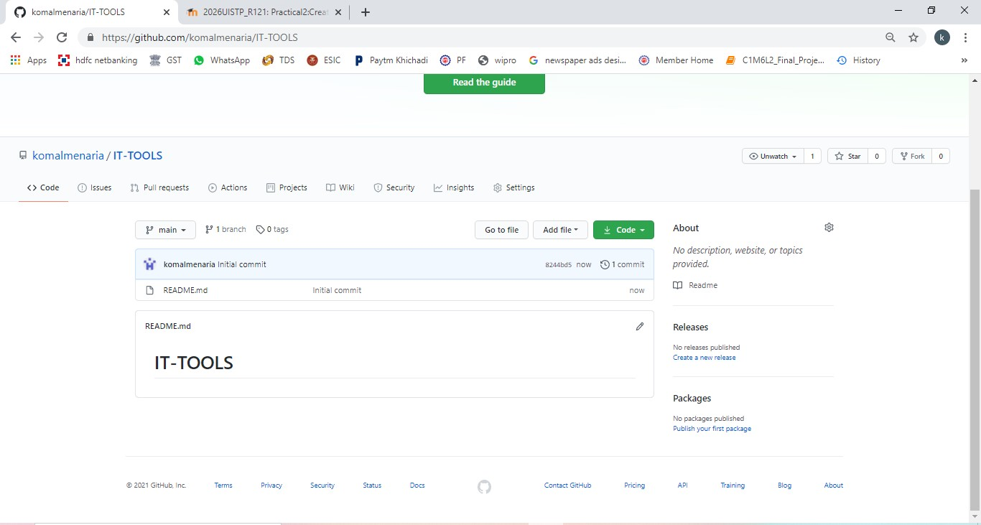

CLICK HERE TO ADD YOUR FILE

Step 2 click on upload files here you can add any no of file in the repository.

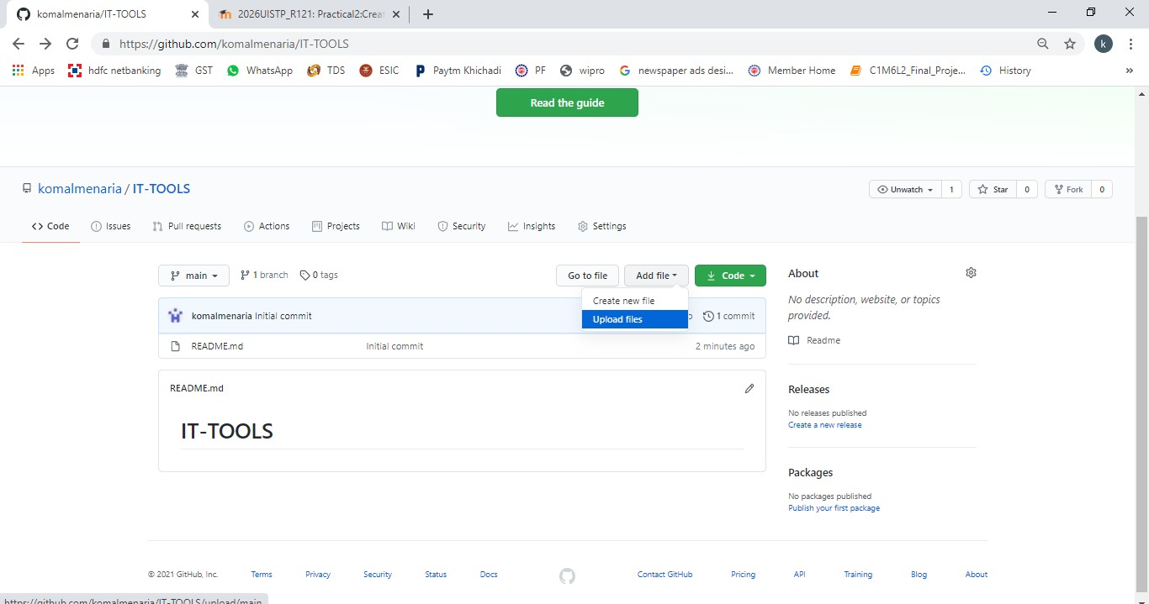

Step 3: Click on choose your files to select your file.

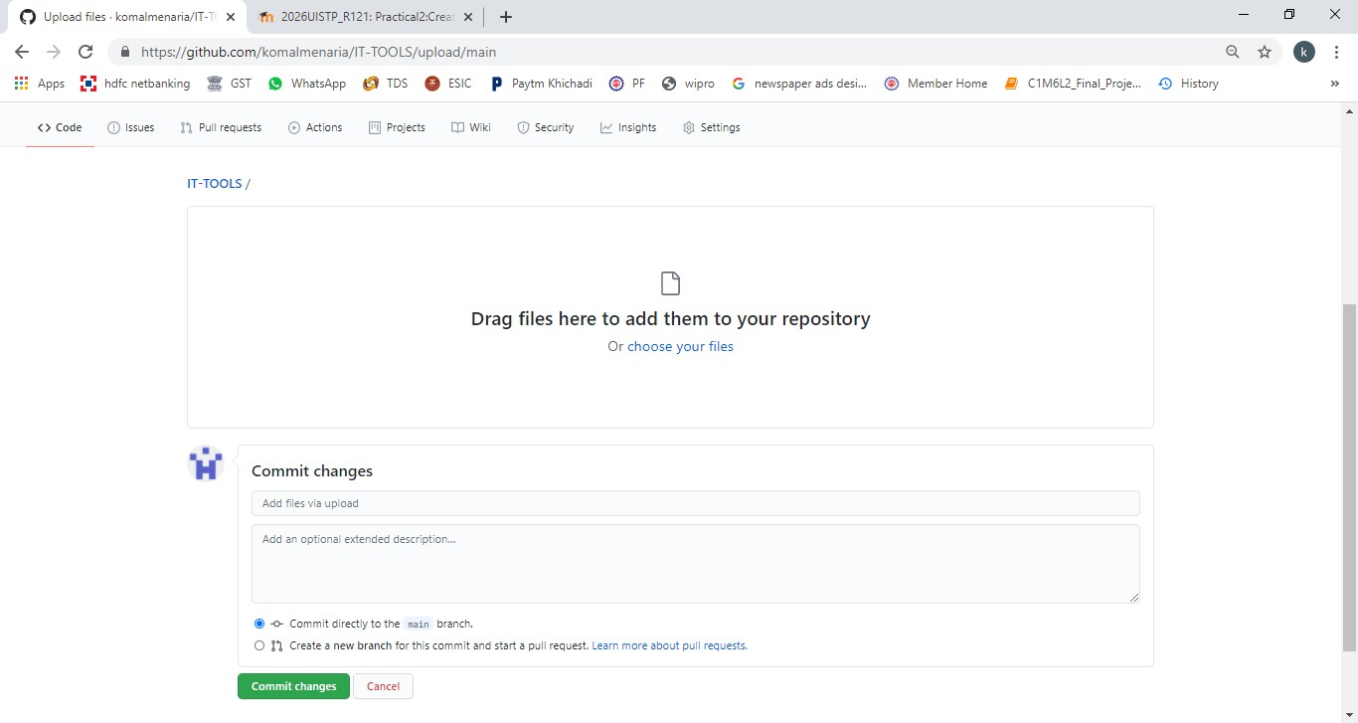

Step 4: Select the file which you want and click on open button and atlast click on the commit changes button to save the changes.

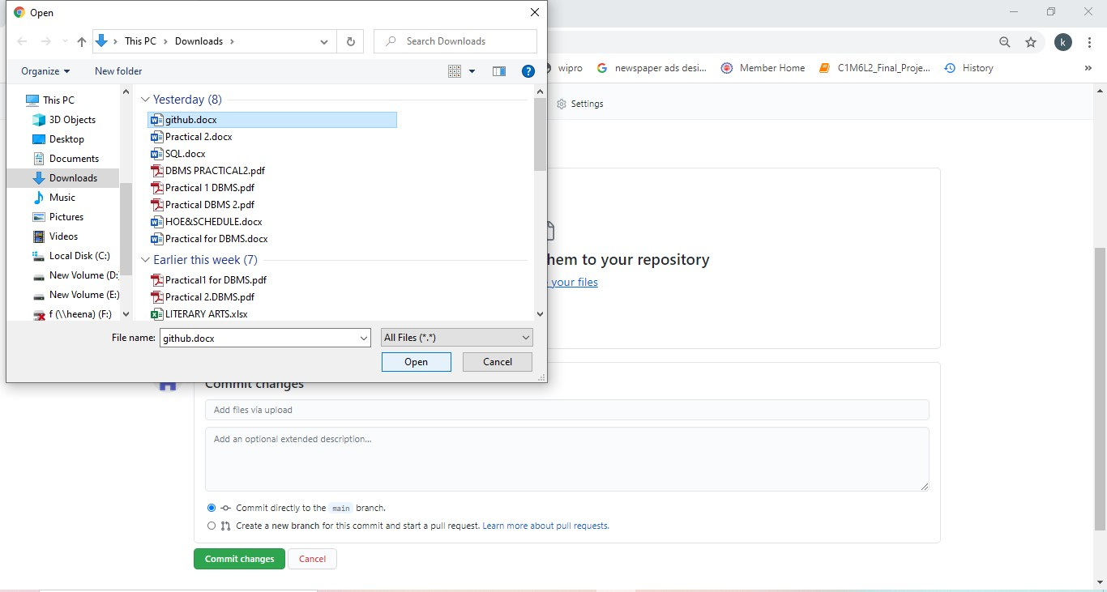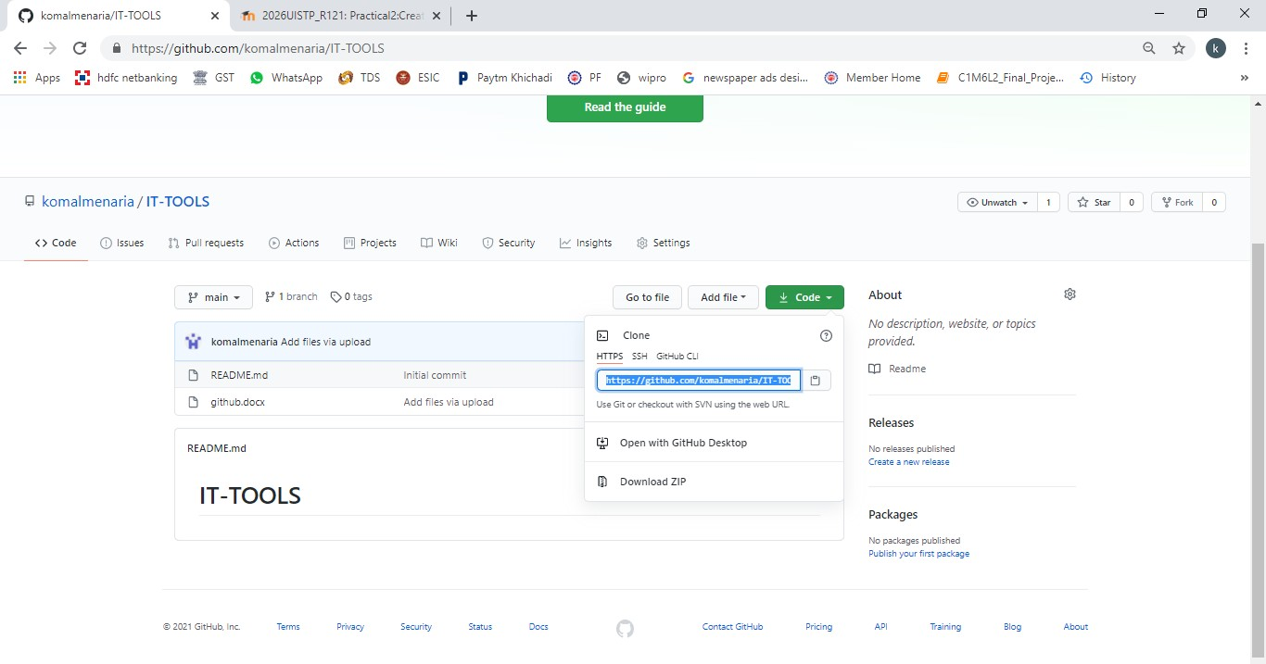

LINK OF THE REPOSITORY

Step 4: click on the code button to get your repository link and copy the link To share your repository.